

ATAR Biology

Unit 2: Topic 4

Week 29: Vascular Plants – Gas Exchange

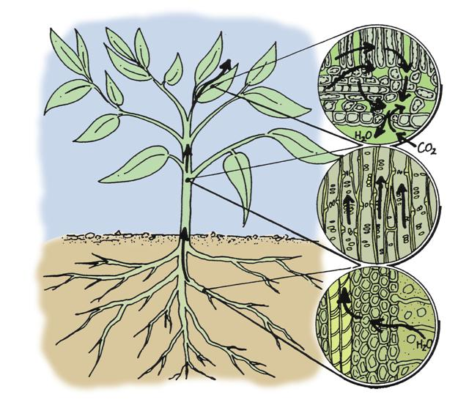
© SIDE

Student Study Notes

Unit Content

- in vascular plants, gases are exchanged via stomata and the plant surface and does not involve the plant transport system
Exchange of gases
Plants have specialised structures and cells to exchange gases with the environment. These structures include lenticels, root hair cells and stomata.
Lenticels
Lenticels are found on fruit and stems. They are openings in the skin or bark which allow gases to be exchanged with the living cells underneath. Lenticels can be seen as tiny dots on the skins of apples, pears and potato tubers.
Root hair cells
Root hair cells have a high surface area to volume (SA:V) ratio to obtain water and exchange gases with the airspaces between soil particles. Oxygen diffuses across the root hair cell membrane and carbon dioxide diffuses out.
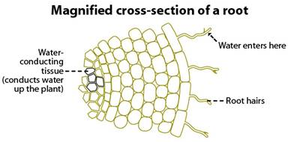
© WestOne

Stomata
Stomata are tiny pores found on the underside of leaves which allow gases to enter or leave the plant. Carbon dioxide enters and is used by leaf cells for photosynthesis. If not used during cellular respiration, excess oxygen produced by photosynthesis will diffuse out of cells and into the air via the stomata. Water vapour also leaves the plant through the stomata. Guard cells enable stomata to open or close.
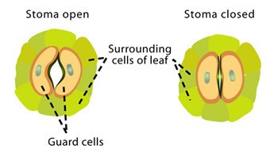
© WestOne
PRACTICE QUESTIONS
1. Why are plants unable to use the carbon dioxide produced by the root hair cells for photosynthesis?

2. Guard cells enable stomata to open or close. In desert plants, stomata close during the heat of the day. Can you suggest why?

3. From your knowledge of diffusion, explain why carbon dioxide continually enters a plant when the stomata are open.

4. Complete the table below to summarise gas exchange structures in plants.
Structure | Where found | Adaptive feature and function
lenticel
stomata
root hair cell

5. Refer to the image below.
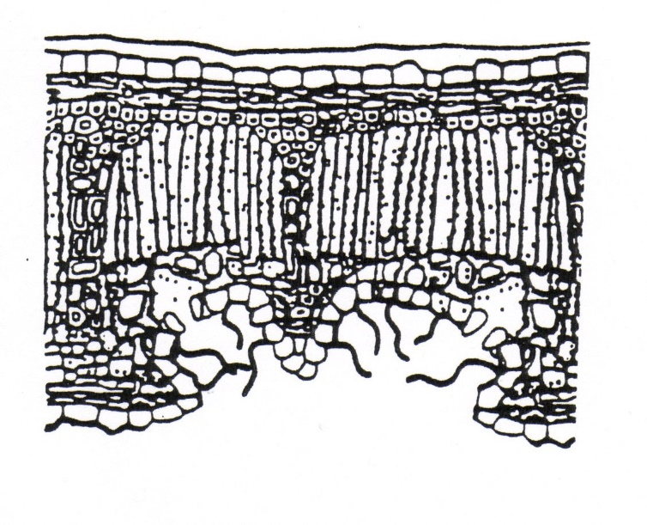
A
D
C
B

The site of gas exchange is labelled as
- structure A
- structure B
- structure C
- structure D

6. Describe the role of lenticels in plant gas exchange.

7. Identify two properties of leaves that assist gas exchange.

8. Identify two adaptations for gas exchange that aquatic plants possess.

9. Which does not assist a plant’s ability to gas exchange?
- Thin leaves.
- Lots of stomata.
- A thick waxy cuticle.
- Lenticels in the stems.

10. Plants have specialised structures and cells to exchange gases with the environment. Name two of these structures and briefly describe how gas exchange occurs. (4 marks)

